[**https://www.kickstarter.com/projects/lavidimus/chris-taylors-arakion/description**](https://www.kickstarter.com/projects/lavidimus/chris-taylors-arakion/description)

Throin

Throin is a group based role-playing dungeon crawler that pays homage the classics while adding its own style with fresh mechanics. Lead a band of three heroes through a broken land, ripped apart by unknown forces.

**Throin**is a modern take on a classic RPG formula. You're put in control of three heroes trying to survive a world devastated by war. Adventuring in Throin will take you across open land, into deep dungeons and even put you in control of rebuilding a desolated town.

A great evil, nearly destroying Throin in ages past, has returned. It is up to you to create a band of heroes to fight this darkness. The game takes place on two continents floating in the sky, as well as hundreds of minor islands. Throin has been marred by war and strife for thousands of years and the landscape is a reflection of that.

* **Character Customization!**Character customization in Throin is a refreshing take on the RPG Level-Up formula. Instead of skills and stats after X experience, your choices throughout the game affect your heroes. From the weapons you choose to forge, to the add-ons you choose for their housing, every decision has an impact on your heroes.
* **You did what with my weapon?!**Each character only starts with one weapon, one set of armor and four skills. You'll use the materials you find in the world to shape and morph your characters in to the heroes they'll become. Every decision you make has a permanent and lasting impact on your hero who resonates in the manner they play and interact with the world.
* **Town Building!**Using building blueprints you find, the people you rescue, along with the help of a mysterious stranger, you'll use ancient devices to rebuild a lost town. You'll have to choose wisely however, as some building decisions permanently prevent other choices.
* **Combat!** Combat in Throin allows you to choose real-time, turn-based or a unique blend of both. The core system of Throin takes two old school styles of gameplay and merging them into one seamless combat experience.
* **Adventure!**You'll adventure through dozens of dungeons, castles and open world areas while finding hidden passageways, collecting materials and crushing your foes.
* **Story!**The game features a deep and engaging story-line that spans generations. As you play through the game you'll learn about the history of Throin and your heroes, as well as taking a part in shaping your heroes past with the unique trait system.

I've been working on Throin every spare moment for some time now. Until a couple of weeks ago, I was mainly focused on getting the ideas down and making sure I could achieve the look, feel and gameplay that I wanted.

Now that the prototype is finished Throin is ready for the next phase of development. While all the basics are done, coded and ready, and the art-style has been defined and refined, I would like to be able to put in the additional hours and potentially hire some extra hands to move it out of the prototype stage and into a full game.

I'll be using Kickstarter to move Throin into this next stage of development; building upon the foundation to bring you a great game. The funding will be used for:

* **Hiring:**A game is not easy to make, so I'll be using Kickstarter funds to hire on the extra hands I need to make Throin a reality.
* **Surviving:**Paying the bills - you know how it goes.
* **Expanding:**Take a look at the stretch chart. I've spent a lot of time crunching the numbers so you know exactly what you're getting for your buck.
* **Software...ing :**The license to use software can be extremely expensive, and while I own most of the software needed to make the game, buying the additional pieces that put that extra layer of polish on it can be very pricey

[https://www.kickstarter.com/projects/heartshapedgames/hero-Genesis/description](https://www.kickstarter.com/projects/heartshapedgames/hero-generations/description)

**Hero Genesis**

Hero Genesis is a quick-playing turn-based strategy game that takes inspiration from rogue-likes, 4X strategy, and independent art games. It has been described as **the** **offspring of** ***Sid Meier’s Civilization***, **Jason Rohrer’s *Passage***, **and *The Legend of Zelda***.

You play a rapidly aging hero that explores a procedurally generated world in search of fame and a mate to settle down with before you die. **After your life ends, you continue on adventuring as your child.** Depending upon your choices, your child will be either more fit to take on the world, or hobbled by your poor decisions.

Hero Genesis is best described as **“The 5-Minute *Civilization*.”** An entire heroic life can be played through in minutes, but chaining together a 2000 year lineage comes from hours of deep strategic play. You move your hero around a procedurally generated grid-based world, and each step they take removes 1 year from their life.

Every turn confronts you with a meaningful choice about how you want to live your life. Do you stay safe and build up your hometown, or explore into the unknown in search of fame and fortune? Do you work to make the world better for your children, or do you selfishly pursue your own dreams?

**Limited Lifespan and Permadeath**: each move your hero makes = 1 year of their life. Each hero has a limited lifespan (from 50-125 years) that puts pressure on you to think carefully about how you spend the years you have left.

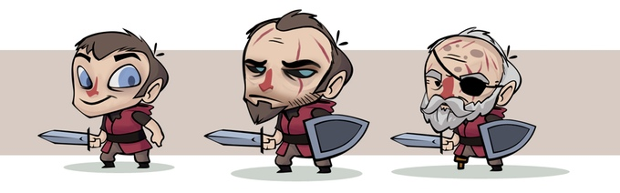Your hero physically ages as you play

**Genesis, Mating, and Having Children:** The world has towns that house mates for you to woo. Successfully finding a mate lets you have a child, and that child becomes the hero you control next in the same world. Choosing the right mate is key, as mates pass on **traits** (special abilities) that make your child more powerful and prepared.

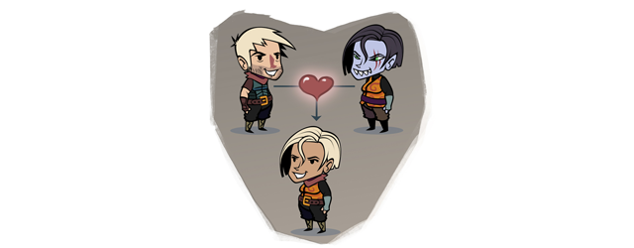

**6 Strategic Paths and Meaningful Choices**: Heroes are judged by how **famous**they become in a single lifespan. Heroes grow and gain fame by completing **quests** and pursuing the following strategic paths:

* ***Strength***: growing in size and strength lets you battle the monsters in your path, and break down barriers to progress.
* ***Love***: work to attract the mate of your dreams, and build an epic legacy of great heroes.
* ***Exploration***: discover what is hidden underneath the clouds, and blaze trails to make traversing the world faster in the future.
* ***Wealth***: collect gold so that you can create buildings in towns or buy items you can pass down to your children.
* ***Fame***: gain fame directly by questing to return ancient artifacts, slaying procedurally generated boss monsters, and competing with other families for the throne.
* ***Building & Technology***: craft amazing towns by building Barracks, Observatories, Museums, and Monuments that offer you helpful resources lasting across Genesis.

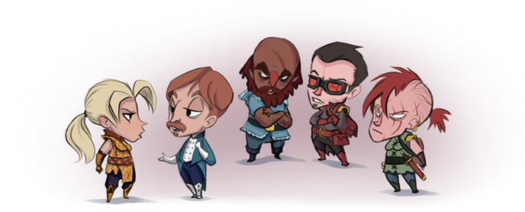

**Building Tech Tree & Family Crafting**: The 4 spaces next to towns allow you to construct special buildings that offer actions and useful resources. Buildings provide long term benefits and influence the **culture**of neighboring towns. Towns morph in response to combinations of buildings nearby, causing the mates in the town to take on unique traits! Examples of discoverable town types include the **Ranch**, **Fortress**, **Ghost Town**, **Port City**, and **Dark Cathedral!**

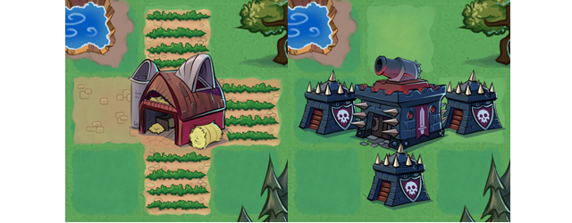

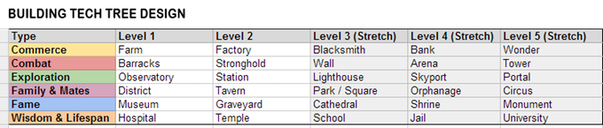Planned Building Tech Tree and Stretch Goals

**Expansive Over world:** Each world of Hero Genesis is a 10x10 procedurally generated grid filled with towns, forests, ancient ruins, monsters, and more. In addition, there is an expansive over world: **a 3x3 grid of connected worlds**. Secret paths at the borders lead to completely different world types. If we meet our stretch goals, we’ll add awesome new world sets that feature totally unique quests, enemies, terrain, and more!

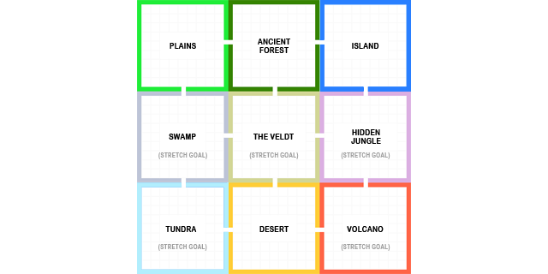

**Prophecies & World Events:** Every 100 years, a major “world event” occurs. Volcanoes erupt; giant creatures emerge hell bent on destroying the world. It can also mean the arrival of helpful special characters, like **wandering** **caravans** and fast traveling **airships**. You’ll be challenged to grow and adapt to an ever-changing world around you.

**Gorgeous Art Style:**The finished game will feature the look and feel I always hoped for, developed by fellow Seattle artist Dominic Sodano. The visuals work to subtly reveal the emotional themes inherent in the game mechanics.

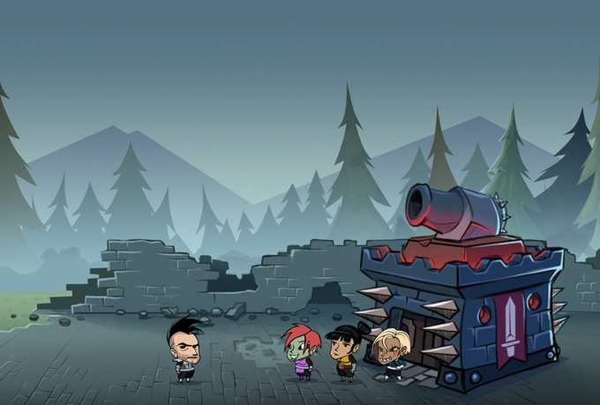

**Simple Yet Deep**: The game system has many elements, but the moment-to-moment gameplay simply involves moving your hero from one grid space to the next like a **rogue-like**. The result is meaningful strategic choices like a 4X Strategy game, but without the heavy micromanagement and calculation.

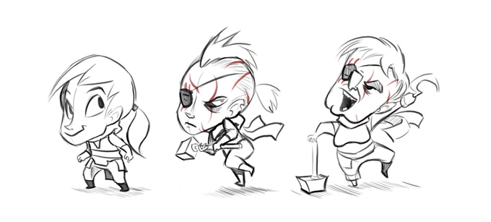Female hero aging along the strength and warrior path.

**Meaning**: The game system was built from the ground up to be an exploration of the themes of death, legacy, family, love, and more. The experience of playing the game I hope will be a surprising and thought-provoking experience, as well as fun. I'll be posting more details on the inspiration and design philosophy behind this in future backer updates.

If we meet our basic funding goal, I will use the funds to convert the prototype into a downloadable, DRM-free version for PC, Mac, and Linux platforms. At a minimum the team and I will implement the following:

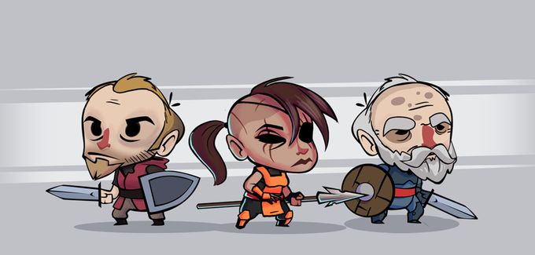

**1. All new art.**We'll create final game art and animation with an all new, polished and fitting style like the mockups and concepts featured on this page.

**2. Support for both male and female heroes.** The prototype supports male heroes and female mates. We'll fix this and add new female hero art.

**3. Over world map.** I'll add support for world tile sets, and procedural generation of the world and connected paths.

**4. New Worlds.** I'll implement a 2nd world type: Desert. In combination with the Grassland and Ancient Forest types, the over world will offer a lot to discover.

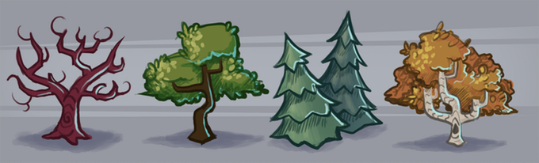

**5. Giant content addition:** I'll add additional character traits, items, quests, enemies, and world events to give all worlds’ long term variety.

**6. Proper mid-term and end game content:** Add the end boss demon and ancient prophecy system to provide goals and tension across many Genesis of heroes.

**7. New UI:** I've learned a lot about what makes a good UI working on Highgrounds, and I'll apply that experience to create a new and streamlined user interface.

**8. Fill out building tech tree with more buildings and building behaviors.**

**9. All new character rig and animations.** We'll update our "paper doll" character system so that characters can be dynamically mated to create new heroes, and have more fluid animations.

**10. Polish:**Fix bugs, improve performance, refactor hacky prototype code, better music and sfx, and generally do all the behind the scenes work necessary to get the game in shape to be deployed as a standalone game that can run across a variety of computers.

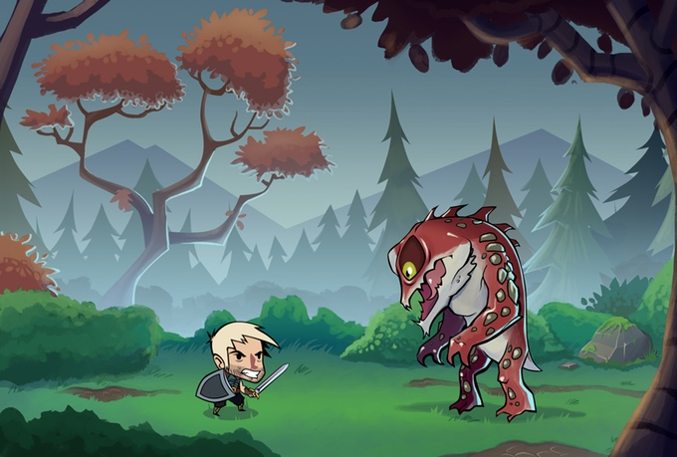

Concept for the battle screen

<https://www.kickstarter.com/projects/magehand/d20pro-unlimited-virtual-tabletop/description>

**Z40**

**For Gamers:**

**Z40** is a powerful, proven application for augmenting your tabletop role-playing games around the dinner table or online around the world. As one of the pioneering virtual tabletops, Z40 is enjoyed by gamers worldwide. Now is your opportunity to participate in a grand mission to remake Z40Pro as Z40Pro Unlimited!

**By Gamers:**

Ten years of development and tens of thousands of gamers around the world have made Z40 a force to be reckoned with. Years of feedback on top of a proven platform provide fertile ground for further development. Your support accelerates how quickly the Z40 Developers can deliver these new killer features.

The existing version of Z40 is available. Any Reward with a Z40 Unlimited License also includes a comparable Z40 Legacy License that you will receive **immediately** following a successful Kick starter. So especially if you play D&D 3.5, Pathfinder, 4e, or the like you can start gaming right away.

<https://www.kickstarter.com/projects/2087444096/pop-up-miniature-terrain-kit/description>

**Pop-Up Diminutive Land Gadget**

**WHY POP-UP land gadget?**

Tabletop Land is seldom destroyed during play. The real problem is storage and transportation. How to you field enough Land to populate a 4x8 table and still have room in your dorm to sleep? The answer is Pop-up Land! It stores easily and can be taken anywhere. Also, it looks sweet!

# "How do I get this pop-up Land?"

By becoming a backer! Silly! For instance, at the $32 level, we'll send you 12inx18in 80 lb. cardstock sheets in SEPIA already printed with the textures. Then you'll cut and assemble them yourself!

# "Do I need anything else?"

You will need to collect some additional tools and supplies:

* An exacto knife
* Glue
* Stiffer material to act as backing (such as foam board, cardboard, or matte board.)

# The Original Goal

Will fund the creation of a kit for making five 12" across (14" from furthest corner to furthest corner) hexagonal pop-up settings.**Along with simple written & comprehensive video instructions.**

<https://www.kickstarter.com/projects/1682698304/wu-and-y-artist-designed-shorts-for-adventures-fes/description>

**Way out: Art on Activewear Shorts**

The first shorts to combine breath-taking art with the comfort of athletic shorts and the utility of fanny packs.

We love to explore, experience, and travel. But our shorts don’t let us do what we want- everyday shorts look okay, but we can’t dance or workout in them. Athletic shorts feel great, but they look odd outside of the gym.

What about one short for them all? Show off your personality in fresh designs from independent artists. Ditch the fanny pack for a secret pocket + 4 zip pockets. Stay comfortable and move in our soft, athletic fabric.

Go to a music festival, backpack across Thailand, or even just work out, all in the same shorts. Let’s Explore!

**Features:**

**Stable Zip Pockets**

* 2 front and back zip pockets
* Sewn into the shorts so you can dance, run, and jump comfortably without your stuff moving around

**Athletic Fabric**

* Premium technical fabric
* Soft + flexible + moisture wicking
* 90% polyester, 10 % spandex

**Designed by Artists**

* Designs from artists around the world
* Artist share revenue
* Crystal clear printing using dye sublimation

**Designed By independent Artists**

The apparel industry often pays to get a pattern for their garment. We’re changing that by finding visionary artist around the world, and sharing our revenue with them. They get paid before we earn a profit.

Your designs can be selected in the survey at the end of the campaign. All designs are available in the male and female fits.

**Do’s**

Music Festivals

Hit the gym

Backpack across Thailand start a conversation about art

Yoga

Tickle fights

Sorcery

Sunset picnic

**Dont’s**

Be a Dick

Insult someone’s dancing litter

Forget to call your mom

Refuse to tip

Leave your tickets at home

<https://www.kickstarter.com/projects/741031201/airbeam-share-and-improve-your-air/description>

AirPlank: Share & Improve Your Air

AirPlank is a wearable air monitor that maps, graphs & crowdsources your pollution exposures in real-time.

Air pollution is a staggering worldwide problem. Sources estimate that poor air quality costs the United States alone over $78 billion dollars annually. The negative impacts of air pollution rank it among the most serious and widespread human health hazards in the world. Breathing dirty air causes chronic illnesses such as asthma and bronchitis and contributes to terminal illnesses such as cancer and heart disease. Unfortunately, despite the very real impacts air pollution has on our everyday lives, it often goes unnoticed because it is largely invisible. In addition, because government-run air quality monitoring networks are sparse, publicly available air quality measurements don’t translate into an accurate assessment of personal exposure. The answer? Low-cost, portable air quality instruments. This is where YOU, AirProjecting, and the AirPlank come in.

**Taking Matter(s) Into Our Own Hands**

AirProjecting is an open-source platform comprised of wearable devices and digital media. It enables AirProjecters (that’s you!) to independently and accurately collects and broadcast air quality data. But at its core, AirProjecting is a DIY air monitoring movement that uses information about local environments to inform, educate, share, and ultimately improve health in communities around the world.

The AirProjecting platform was built as an open-source, end-to-end solution for collecting, displaying, and sharing health and environmental data using your smartphone. The platform consists of wearable sensors that detect changes in your environment and physiology, including a palm-sized air quality monitor called the AirPlank and wearable LED accessories. By documenting and leveraging health and environmental data to inform personal decision-making and public policy, the AirProjecting platform empowers citizen scientists and change makers like you and me to *take matters into our own hands.*

**What is AirPlank and how it works?**

Currently, the AirProjecting platform connects a series of wearable devices to a network, notably an Arduino-powered, portable, palm-sized air quality monitor called the AirPlank. The AirPlank measures fine particulate matter, also known as PM2.5. You may be saying to yourself, “Why is this important?” Answer: The US Environmental Protection Agency monitors and regulates six criteria air pollutants, one of which is PM2.5, and the EPA’s measurements indicate that PM2.5 levels pose a substantial health risk in cities across the country.

PM2.5, describes the size of the particles measured, particles smaller than 2.5 microns in diameter. These tiny particles, 30 of which could fit across the width of a human hair, are a huge problem all around the world. Sources of PM2.5 include diesel cars and trucks, coal burning power plants, forest fires, and construction activities. Because PM2.5 particles are so small, they are able to penetrate deep into our lungs and even pass into our bloodstream causing both short-term affects, like asthma attacks, and long-term effects, like cancer and heart disease.

The AirPlank uses a light scattering method to measure PM2.5. Air is drawn through a sensing chamber wherein light from an LED bulb scatters off particles in the airstream. This light scatter is registered by a detector and converted into a measurement that estimates the number of particles in the air. Via Bluetooth, these measurements are communicated approximately once a second to the AirProjecting app, which maps and graph the data in real time on your smartphone. At the end of each AirProjecting session, the collected data is sent to the AirProjecting website, where the data is crowdsourced with data from other AirProjecting to generate heat maps indicating where PM2.5 concentrations are highest and lowest. As an open-source platform, modifying our components to take other measurements and or transmit the data to other websites or apps is easy and encouraged. We’ve even included an expansion port on the AirPlank to make adding sensors as simple as can be.

**Wait, There's More**

Staring at a screen can be a drag (and may lead to being run over while walking or biking!) so we developed the LiteBeam to communicate the AirPlank measurements using LEDs. The LiteBeam uses a IOIO microcontroller connected to the AirProjecting app over Bluetooth to illuminate LEDs in response to the sensor measurements received by the AirProjecting app: green for low intensity, then yellow, then orange, and red for high intensity. We'll be publishing an Instruct able for the LiteBeam after we reach our crowdfunding goal.

<https://www.kickstarter.com/projects/tylerchintanner/broken-frontier-the-boldest-comics-anthology-in-th/description>

**Crippled bound**

A creator-owned anthology about breaking boundaries and exploring the great unknown by the most inventive talents in comics.

Over **250 full color pages**. More than **40** **incredibly talented creators**, **27** **amazing stories**, 1 beautifully designed **over-sized hardcover**. But above all: **a comic book experience you won't find anywhere else!**

All wrapped in a **stunning cover**, the crippled bound Anthology is beautifully designed and assembled with the highest production value. Larger than a standard graphic novel, the book’s 11.2''x7.6'' format allows the amazing artwork and stories to leap off the page.

**About the amazing stories inside**

The book has everything: The last man in the galaxy? Check! An immortal on the edges of the universe? You bet! Cosmic horror on previously unimagined scale? Of course! The list goes on: Time travel, dystopian deserts, bewildered Vikings stumbling upon the supernatural. Yes, Vikings, because why the hell not?!

You’ll also see some dimension hopping, an existential murder mystery, a man digging to the center of the Earth... and much more!

<https://www.kickstarter.com/projects/steamforged/dark-soulstm-the-board-game/description>

**Vile Spirit**

Vile Spirit - The Board Game is a strategically challenging, deeply immersive combat exploration game for 1-4 players set in the Vile Spirit universe. Players choose from a number of core character classes and explore dangerous locations full of monsters, treasures, and deadly boss fights.

Designed specifically for the Vile Spirit™ universe and introducing a number of innovative gameplay mechanics, with world-class miniatures faithful to the rich universe, this game delivers an experience that captures the very essence of the original video games.

We don’t like complicated Kickstarter, so we’ve made this one as simple as possible. There is just **one** pledge level for gamers, and **one** pledge for retail stores.

As the campaign progresses, some stretch goals will unlock an ‘Add-On’ which is an optional item to purchase; to buy one of these, simply increase your pledge amount. This also drives the campaign totals up thereby unlocking even more stuff!

The best bit is that every '**non**Add-On' stretch goal that gets unlocked during the campaign will be included in your pledge! So the more people that support the project, the more goals get unlocked, the more value we can squeeze in, and the bigger the box we're going to need!

Vile Spirit - The Board Game is much more than a classic dungeon crawler. Just like the Vile Spirit video games, this is a game that requires strategic thinking, clever planning, and exemplary execution to succeed.

To triumph, players must explore dangerous locations, discover and defeat enemies, and collect equipment and treasures before ultimately facing the boss in an epic fight to the death.

Playable in either Solo or Co-op modes, players choose their role from a number of core Vile Spirit character classes. Each class has a distinct role to play in the game, with a unique set of strengths and abilities.

With multiple difficulty modes and a high-level of replay ability, this is a game designed to be deep enough to satisfy hard-core tabletop gamers whilst remaining accessible to newer players.

Veil Spirit - The Board Game features an exciting "fast setup, long reveal" mechanic that gets you into the game faster and builds the location and encounters as you explore.

With no fixed scenario layouts, it’s as simple as choosing the direction to explore, placing a new tile down and flipping a card from the Encounter deck.

Each time you decide where to go, you will experience a new danger as you explore, with each new location a real risk to your hard-won progress. If you die, then you drop everything you have collected and reappear at the nearest bonfire. So do you return to the bonfire to rest and spend Souls to strengthen up, but in doing so fully reset the locations? Or do you press on and pray that the next encounter isn’t beyond your capabilities? After all, the next location may contain a clue to the Boss and how to defeat them…

Combat is both fast and deadly. Veil Spirit - The Board Game rewards clever players and punishes ‘button mashing’. Players must learn enemy behaviors in order to fight more effectively, with classic fighting game style combat windows.

The game features a “dynamic positioning system” which makes combat fluid and ever-changing. With the game state constantly shifting as combatants move around the battlefield, players must stay alert to danger and opportunities.

Equipment, armor, and weapons are discovered or earned during play, but with limited slots players must think carefully about what is best to keep and use. Using a simple stamina management system, players can potentially leave themselves exhausted and vulnerable. Death is usually swift to follow a poor decision in combat.

Using our advanced miniatures development pipeline and working with one of the finest board game manufacturers in the world, the quality and detail in the miniatures is world-class. With the entirety of the Veil Spirit universe available to use, one of the hardest decisions has been to narrow down which enemies and bosses to include in the core game.